**Introduction**

## **What is EPANET:**

## EPANET is a computer program that performs extended period simulation of hydraulic and water quality behaviour within pressurized pipe networks. A network consists of pipes, nodes (pipe junctions), pumps, valves and storage tanks or reservoirs. EPANET tracks the flow of water in each pipe, the pressure at each node, the height of water in each tank, and the concentration of a chemical species throughout the network during a simulation period comprised of multiple time steps. In addition to chemical species, water age and source tracing can also be simulated.

## **Steps in Using EPANET:**

One typically carries out the following steps when using EPANET to model a water distribution system:

1. Draw a network representation of your distribution system or import a basic description of the network placed in a text file.
2. Edit the properties of the objects that make up the system.
3. Describe how the system is operated.
4. Select a set of analysis options.
5. Run a hydraulic/water quality analysis
6. View the results of the analysis

**Installing EPANET:**

## EPANET Version 2.2 is designed to run under the Windows 7/8/10 operating system of an Intel-compatible personal computer. It is distributed as a single installer package file, **epanet2.2\_setup.exe**.

**EPANET’s Workspace**

**Overview:**

The basic EPANET workspace is pictured below. It consists of the following user interface elements: A Menu Bar, two Toolbars, a Status Bar, the Network Map window, a Browser window, and a Property Editor window

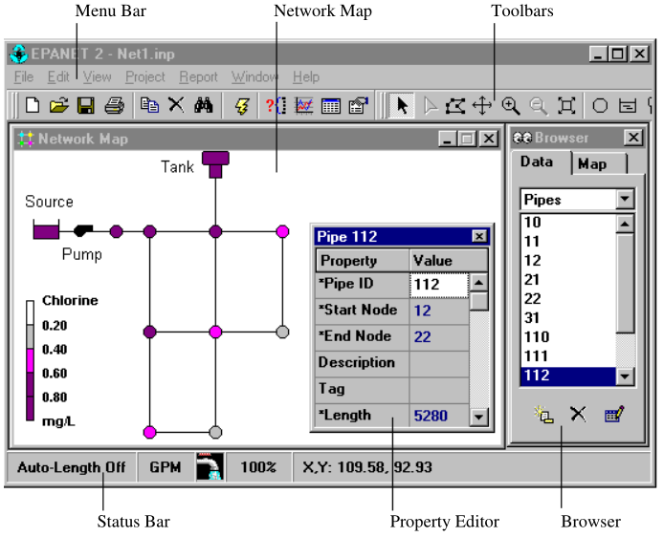

## **Menu Bar:**

The Menu Bar located across the top of the EPANET workspace contains a collection of menus used to control the program. These include:

* File Menu
* Edit Menu
* View Menu
* Project Menu
* Report Menu
* Window Menu
* Help Menu

**File Menu:**

The File Menu contains commands for opening and saving data files and for printing.

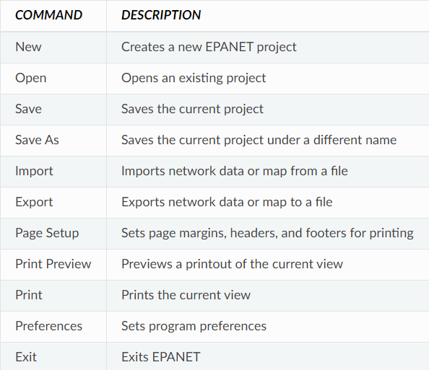

**Edit Menu:**

The Edit Menu contains commands for editing and copying.

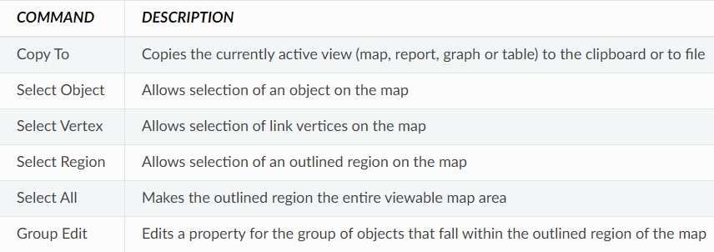

**View Menu:**

The View Menu controls how the network map is viewed.

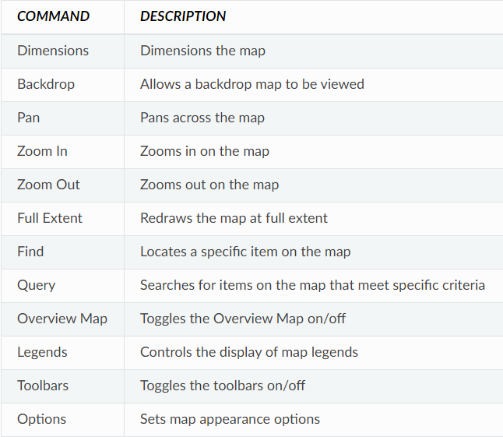

**Project Menu:**

The Project Menu includes commands related to the current project being analysed.

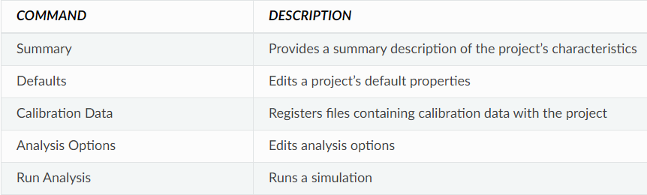

**Report Menu:**

The Report menu has commands used to report analysis results in different formats.

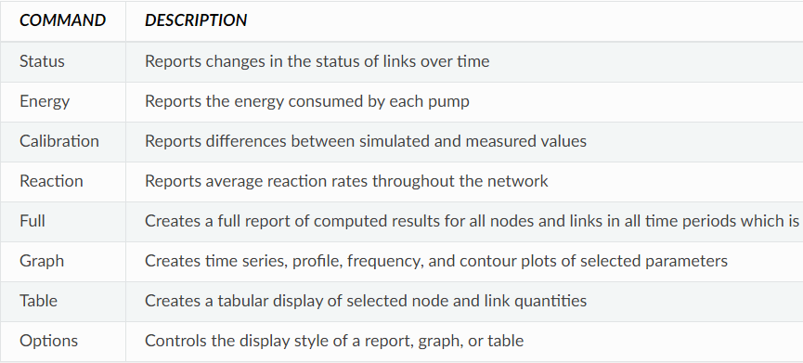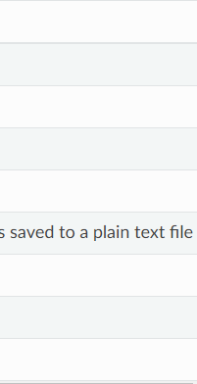

**Window Menu:**

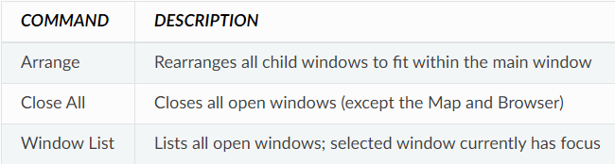

**Help Menu:**

The Help Menu contains commands for getting help in using EPANET. Context-sensitive Help is also available by pressing the F1 key.

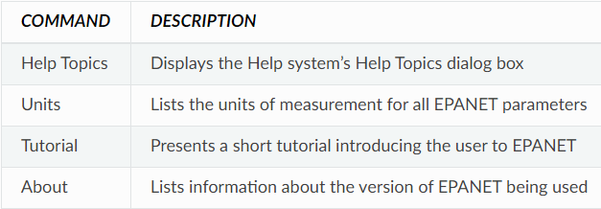

**Toolbars:**



Toolbars provide shortcuts to commonly used operations. There are two such toolbars:

* Standard Toolbar
* Map Toolbar

**Standard Toolbar:**

The Standard Toolbar contains speed buttons for commonly used commands.

* image40 Opens a new project (**File >> New**)
* image41 Opens an existing project (**File >> Open**)
* image42 Saves the current project (**File >> Save**)
* image43 Prints the currently active window (**File >> Print**)
* image45 Copies selection to the clipboard or to a file (**Edit >> Copy To**)
* image46 Deletes the currently selected item
* image44 Finds a specific item on the map (**View >> Find**)
* image48 Runs a simulation (**Project >> Run Analysis**)
* image47 Runs a visual query on the map (**View >> Query**)
* image49 Creates a new graph view of results (**Report >> Graph**)
* image50 Creates a new table view of results (**Report >> Table**)
* image51 Modifies options for the currently active view (**View >> Options**)

**Map Toolbar:**

The Map Toolbar contains buttons for working with the Network Map.

* image52 Selects an object on the map (**Edit >> Select Object**)
* image53 Selects link vertex points (**Edit >> Select Vertex**)
* image54 Selects a region on the map (**Edit >> Select Region**)
* image55 Pans across the map (**View >> Pan**)
* image56 Zooms in on the map (**View >> Zoom In**)
* image57 Zooms out on the map (**View >> Zoom Out**)
* image58 Draws map at full extent (**View >> Full Extent**)
* image59 Adds a junction to the map
* image60 Adds a reservoir to the map
* image61 Adds a tank to the map
* image62 Adds a pipe to the map
* image63 Adds a pump to the map
* image64 Adds a valve to the map
* image65 Adds a label to the map

## **Status Bar:**



The Status Bar appears at the bottom of the EPANET workspace and is divided into four sections which display the following information:

* **Auto-Length** – indicates whether automatic computation of pipe lengths is turned on or off
* **Flow Units** - displays the current flow units that are in effect
* **Zoom Level** - displays the current zoom in level for the map (100% is full scale)
* **Run Status** - a faucet icon shows:
  + No running water if no analysis results are available,
  + Running water when valid analysis results are available,
  + A broken faucet when analysis results are available but may be invalid because the network data have been modified.
* **XY Location** - displays the map coordinates of the current position of the mouse pointer.

## **Network Map:**

The Network Map provides a planar schematic diagram of the objects comprising a water distribution network.

**Data Browser:**

The Data Browser is accessed from the Data tab on the Browser window. It gives access to the various objects, by category (Junctions, Pipes, etc.) that are contained in the network being analysed. The buttons at the bottom are used to add, delete, and edit these objects.

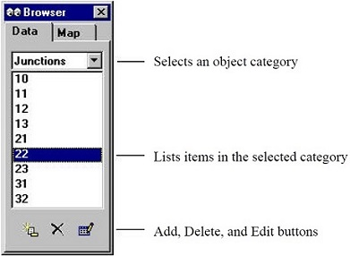

## **Map Browser:**

The Map Browser is accessed from the Map tab of the Browser Window. It selects the parameters and time period that are viewed in color-coded fashion on the Network Map. It also contains controls for animating the map through time.

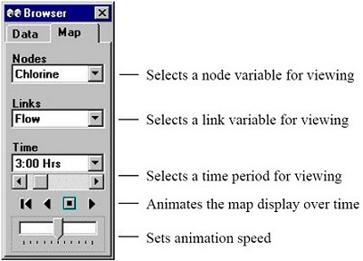

The animation control pushbuttons on the Map Browser work as follows:

image68 Rewind (return to initial time)

image68_2 Animate back through time

image68_3 Stop the animation

image68_4 Animate forward in time

## **Property Editor:**

The Property Editor is used to edit the properties of network nodes, links, labels, and analysis options.

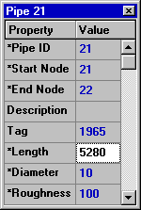

* The Editor is a grid with two columns - one for the property’s name and the other for its value.
* An asterisk next to a property name means that it is a required property – its value cannot be left blank.
* To begin editing the property with the focus, either begin typing a value or hit the Enter key.
* To have EPANET accept what you have entered, press the Enter key or move to another property; to cancel, press the Esc key.

**Working with Projects**

## **Project Defaults:**

Each project has a set of default values that are used unless overridden by the EPANET user. These values fall into three categories:

* Default ID labels (labels used to identify nodes and links when they are first created)
* Default node/link properties (e.g., node elevation, pipe length, diameter, and roughness)
* Default hydraulic analysis options (e.g., system of units, Headloss equation, etc.)

To set default values for a project:

1. Select **Project >> Defaults** from the Menu Bar.
2. A Defaults dialog form will appear with three pages, one for each category listed above.
3. Check the box in the lower right of the dialog form if you want to save your choices for use in all new future projects as well.
4. Click **OK** to accept your choice of defaults.

**Default ID Labels:**

The ID Labels tab of the Defaults dialog form is used to determine how EPANET will assign default ID labels to network components when they are first created. Then one supplies an increment to be used when adding a numerical suffix to the default label.

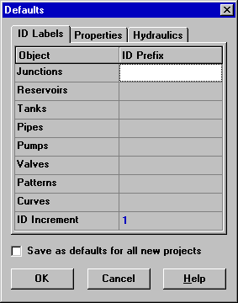

**Default Node/Link Properties:**

The Properties tab of the Defaults dialog form sets default property values for newly created nodes and links. These properties include:

* Elevation for nodes
* Diameter for tanks
* Maximum water level for tanks
* Length for pipes
* Auto-Length (automatic calculation of length) for pipes
* Diameter for pipes
* Roughness for pipes

When the Auto-Length property is turned on, pipe lengths will automatically be computed as pipes are added or repositioned on the network map. A node or link created with these default properties can always be modified later on using the Property Editor.

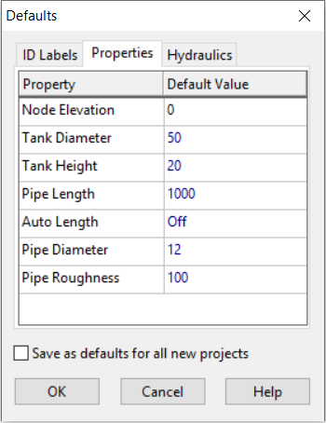

**Default Hydraulic Options:**

The third tab of the Defaults dialog form is used to assign default hydraulic analysis options. It contains a sub-set of the project’s Hydraulic Options that can also be accessed from the Browser. The most important Hydraulic Options to check when setting up a new project are Flow Units, Headloss Formula, and Default Pattern. The choice of Flow Units determines whether all other network quantities are expressed in Customary US units or in SI metric units. The choice of Headloss Formula defines the type of the roughness coefficient to be supplied for each pipe in the network. The Default Pattern automatically becomes the time pattern used to vary demands in an extended period simulation for all junctions not assigned any pattern.

**Working with Objects**

## **Editing Visual Objects:**

The Property Editor is used to edit the properties of objects that can appear on the Network Map. To edit one of these objects, select the object on the map.

**The Junction Properties**

|  |  |
| --- | --- |
| **PROPERTY** | **DESCRIPTION** |
| Junction ID | A unique label used to identify the junction. It can consist of a combination of up to 15 numerals or characters. It cannot be the same as the ID for any other node. This is a required property. |
| X-Coordinate | The horizontal location of the junction on the map, measured in the map’s distance units. If left blank the junction will not appear on the network map. |
| Y-Coordinate | The vertical location of the junction on the map, measured in the map’s distance units. If left blank the junction will not appear on the network map. |
| Description | An optional text string that describes other significant information about the junction. |
| Tag | An optional text string (with no spaces) used to assign the junction to a category, such as a pressure zone. |
| Elevation | The elevation in feet (meters) above some common reference of the junction. This is a required property. |
| Base Demand | The average or nominal demand for water by the main category of consumer at the junction, as measured in the current flow units. A negative value is used to indicate an external source of flow into the junction. If left blank then demand is assumed to be zero. |
| Demand Pattern | The ID label of the time pattern used to characterize time variation in demand for the main category of consumer at the junction. The pattern provides multipliers that are applied to the Base Demand to determine actual demand in a given time period. If left blank then the **Default Time Pattern** assigned in the Hydraulic Options will be used |
| Demand Categories | Number of different categories of water users defined for the junction. Click the ellipsis button (or hit the Enter key) to bring up a special Demands Editor which will let you assign base demands and time patterns to multiple categories of users at the junction. Ignore if only a single demand category will suffice |
| Emitter Coefficient | Discharge coefficient for emitter (sprinkler or nozzle) placed at junction. The coefficient represents the flow (in current flow units) that occurs at a pressure drop of 1 psi (or meter). Leave blank if no emitter is present. |
| Initial Quality | Water quality level at the junction at the start of the simulation period. Can be left blank if no water quality analysis is being made or if the level is zero. |
| Source Quality | Quality of any water entering the network at this location. Click the ellipsis button to bring up the Source Quality Editor |

**The Reservoir Properties**

|  |  |
| --- | --- |
| **PROPERTY** | **DESCRIPTION** |
| Reservoir ID | A unique label used to identify the reservoir. It can consist of a combination of up to 15 numerals or characters. It cannot be the same as the ID for any other node. This is a required property. |
| X-Coordinate | The horizontal location of the reservoir on the map, measured in the map’s distance units. If left blank the reservoir will not appear on the network map. |
| Y-Coordinate | The vertical location of the reservoir on the map, measured in the map’s distance units. If left blank the reservoir will not appear on the network map. |
| Description | An optional text string that describes other significant information about the reservoir. |
| Tag | An optional text string (with no spaces) used to assign the reservoir to a category, such as a pressure zone |
| Total Head | The hydraulic head (elevation + pressure head) of water in the reservoir in feet (meters). This is a required property. |
| Head Pattern | The ID label of a time pattern used to model time variation in the reservoir’s head. Leave blank if none applies. This property is useful if the reservoir represents a tie-in to another system whose pressure varies with time. |
| Initial Quality | Water quality level at the reservoir. Can be left blank if no water quality analysis is being made or if the level is zero. |
| Source Quality | Quality of any water entering the network at this location. Click the ellipsis button to bring up the Source Quality Editor. |

**The Tank Properties**

|  |  |
| --- | --- |
| **PROPERTY** | **DESCRIPTION** |
| Tank ID | A unique label used to identify the tank. It can consist of a combination of up to 15 numerals or characters. It cannot be the same as the ID for any other node. This is a required property. |
| X-Coordinate | The horizontal location of the tank on the map, measured in the map’s scaling units. If left blank the tank will not appear on the network map. |
| Y-Coordinate | The vertical location of the tank on the map, measured in the map’s scaling units. If left blank the tank will not appear on the network map. |
| Description | Optional text string that describes other significant information about the tank. |
| Tag | Optional text string (with no spaces) used to assign the tank to a category, such as a pressure zone |
| Elevation | Elevation above a common datum in feet (meters) of the bottom shell of the tank. This is a required property. |
| Initial Level | Height in feet (meters) of the water surface above the bottom elevation of the tank at the start of the simulation. This is a required property. |
| Minimum Level | Minimum height in feet (meters) of the water surface above the bottom elevation that will be maintained. The tank will not be allowed to drop below this level. This is a required property. |
| Maximum Level | Maximum height in feet (meters) of the water surface above the bottom elevation that will be maintained. The tank will not be allowed to rise above this level. This is a required property. |
| Diameter | The diameter of the tank in feet (meters). For cylindrical tanks this is the actual diameter. For square or rectangular tanks, it can be an equivalent diameter equal to 1.128 times the square root of the cross-sectional area. For tanks whose geometry will be described by a curve it can be set to any value. This is a required property. |
| Minimum Volume | The volume of water in the tank when it is at its minimum level, in cubic feet (cubic meters). This is an optional property, useful mainly for describing the bottom geometry of non-cylindrical tanks where a full volume versus depth curve will not be supplied |
| Volume Curve | The ID label of a curve used to describe the relation between tank volume and water level. If no value is supplied then the tank is assumed to be cylindrical. |
| Mixing Model | The type of water quality mixing that occurs within the tank |
| Mixing Fraction | The fraction of the tank’s total volume that comprises the inlet-outlet compartment of the two-compartment (2COMP) mixing model. Can be left blank if another type of mixing model is employed. |
| Reaction Coefficient | The bulk reaction coefficient for chemical reactions in the tank. |
| Initial Quality | Water quality level in the tank at the start of the simulation. Can be left blank if no water quality analysis is being made or if the level is zero. |
| Source Quality | Quality of any water entering the network at this location. Click the ellipsis button to bring up the Source Quality Editor |

**The Pipe Properties**

|  |  |
| --- | --- |
| **PROPERTY** | **DESCRIPTION** |
| Pipe ID | A unique label used to identify the pipe. It can consist of a combination of up to 15 numerals or characters. It cannot be the same as the ID for any other link. This is a required property. |
| Start Node | The ID of the node where the pipe begins. This is a required property. |
| End Node | The ID of the node where the pipe ends. This is a required property. |
| Description | An optional text string that describes other significant information about the pipe. |
| Tag | An optional text string (with no spaces) used to assign the pipe to a category, perhaps one based on age or material |
| Length | The actual length of the pipe in feet (meters). This is a required property. |
| Diameter | The pipe diameter in inches (mm). This is a required property. |
| Roughness | The roughness coefficient of the pipe. This is a required property. |
| Loss Coefficient | Unitless minor loss coefficient associated with bends, fittings, etc. Assumed 0 if left blank. |
| Initial Status | Determines whether the pipe is initially open, closed, or contains a check valve. If a check valve is specified then the flow direction in the pipe will always be from the Start node to the End node. |
| Bulk Coefficient | The bulk reaction coefficient for the pipe |
| Wall Coefficient | The wall reaction coefficient for the pipe |

**The Pump Properties**

|  |  |
| --- | --- |
| **PROPERTY** | **DESCRIPTION** |
| Pump ID | A unique label used to identify the pump. It can consist of a combination of up to 15 numerals or characters. It cannot be the same as the ID for any other link. This is a required property. |
| Start Node | The ID of the node on the suction side of the pump. This is a required property |
| End Node | The ID of the node on the discharge side of the pump. This is a required property |
| Description | An optional text string that describes other significant information about the pump. |
| Tag | An optional text string (with no spaces) used to assign the pump to a category, perhaps based on age, size or location |
| Pump Curve | The ID label of the pump curve used to describe the relationship between the head delivered by the pump and the flow through the pump. Leave blank if the pump will be a constant energy pump. |
| Power | The power supplied by the pump in horsepower (kw). Assumes that the pump supplies the same amount of energy no matter what the flow is. Leave blank if a pump curve will be used instead. |
| Speed | The relative speed setting of the pump (unitless). For example, a speed setting of 1.2 implies that the rotational speed of the pump is 20% higher than the normal setting. |
| Pattern | The ID label of a time pattern used to control the pump’s operation. The multipliers of the pattern are equivalent to speed settings. A multiplier of zero implies that the pump will be shut off during the corresponding time period. Leave blank if not applicable. |
| Initial Status | State of the pump (open or closed) at the start of the simulation period. |
| Efficiency Curve | The ID label of the curve that represents the pump’s wire-to-water efficiency (in percent) as a function of flow rate. This information is used only to compute energy usage. Leave blank if not applicable. |
| Energy Price | The average or nominal price of energy in monetary units per kw-hr. Used only for computing the cost of energy usage. Leave blank if not applicable. |
| Price Pattern | The ID label of the time pattern used to describe the variation in energy price throughout the day. Each multiplier in the pattern is applied to the pump’s Energy Price to determine a time-of-day pricing for the corresponding period. Leave blank if not applicable. |

## **Editing Non-Visual Objects:**

Curves, Time Patterns, and Controls have special editors that are used to define their properties. To edit one of these objects, select the object from the Data Browser and then click the Edit button image88.

**Curve Editor:**

To use the Curve Editor, enter values for the following items:

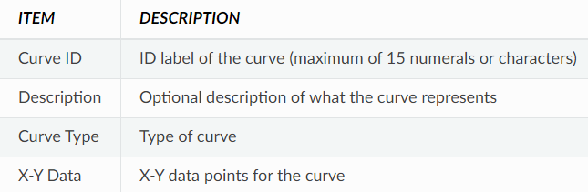

As you move between cells in the X-Y data table (or press the Enter key) the curve is redrawn in the preview window. For single- and three-point pump curves, the equation generated for the curve will be displayed in the Equation box. Click the **OK** button to accept the curve or the **Cancel** button to cancel your entries. You can also click the **Load** button to load in curve data that was previously saved to file or click the **Save** button to save the current curve’s data to a file.

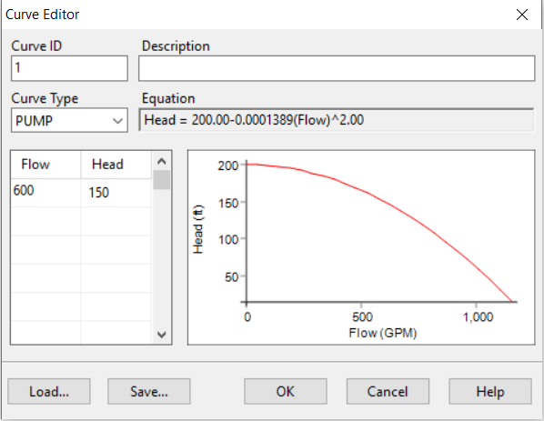

**Pattern Editor:**

To use the Pattern Editor, enter values for the following items:

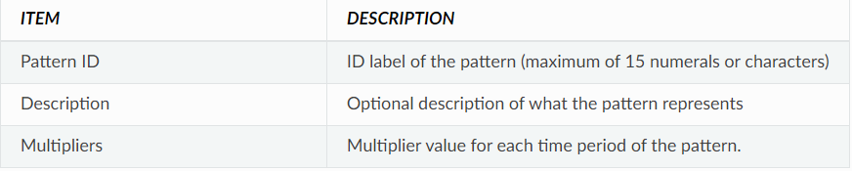

As multipliers are entered, the preview chart is redrawn to provide a visual depiction of the pattern. If you reach the end of the available Time Periods when entering multipliers, simply hit the **Enter** key to add on another period. When finished editing, click the **OK** button to accept the pattern or the **Cancel** button to cancel your entries. You can also click the **Load** button to load in pattern data that was previously saved to file or click the **Save** button to save the current pattern’s data to a file.

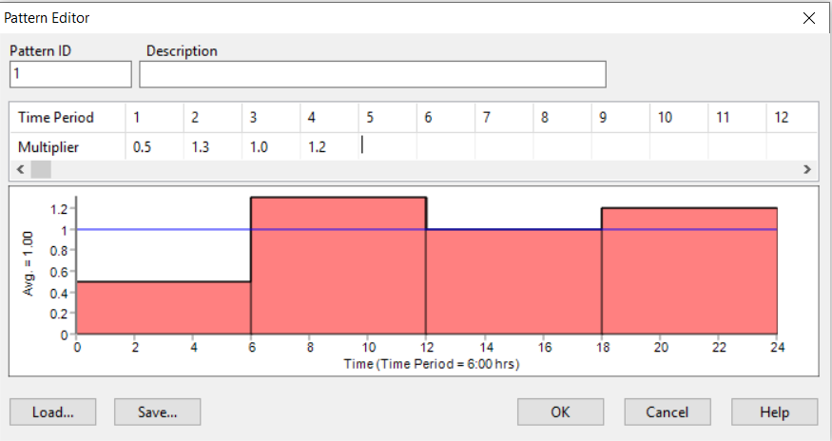

**Working with the Map**

## **Setting the Map’s Dimensions:**

The physical dimensions of the map must be defined so that map coordinates can be properly scaled to the computer’s video display. To set the map’s dimensions:

1. Select **View >> Dimensions**.
2. Enter new dimension information into the Map Dimensions dialog that appears or click the **Auto-Size** button to have EPANET compute dimensions based on the coordinates of objects currently included in the network.
3. Click the **OK** button to re-size the map.

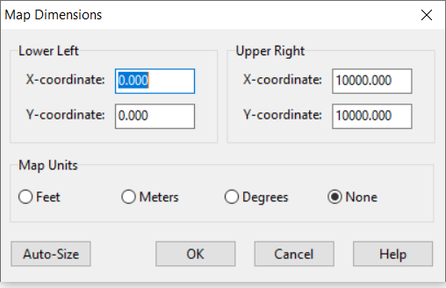

## **Map Legends:**

There are three types of map legends that can be displayed. The Node and Link Legends associate a colour with a range of values for the current parameter being viewed on the map. The Time Legend displays the clock time of the simulation time period being viewed. To display or hide any of these legends check or uncheck the legend from the **View >> Legends** menu. Double-clicking the mouse over it can also hide a visible legend.

To edit the Node Legend:

1. Either select **View >> Legends >> Modify >> Node** or right-click on the legend if it is visible.
2. Use the Legend Editor dialog form that appears to modify the legend’s colours and intervals.

A similar method is used to edit the Link Legend.

The Legend Editor is used to set numerical ranges to which different colours are assigned for viewing a particular parameter on the network map. It works as follows:

* Numerical values, in increasing order, are entered in the edit boxes to define the ranges. Not all four boxes need to have values.
* To change a colour, click on its colour band in the Editor and then select a new colour from the Colour Dialog box that will appear.
* Click the **Equal Intervals** button to assign ranges based on dividing the range of the parameter at the current time period into equal intervals.
* Click the **Equal Quantiles** button to assign ranges so that there are equal numbers of objects within each range, based on values that exist at the current time period.
* The **Colour Ramp** button is used to select from a list of built-in colour schemes.
* The **Reverse Colours** button reverses the ordering of the current set of colours
* Check **Framed** if you want a frame drawn around the legend.

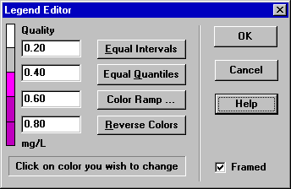

## **Map Display Options:**

* Select **View >> Options**
* Click the Options button image110 on the Standard Toolbar when the Map window has the focus
* Right-click on any empty portion of the map and select **Options** from the popup menu that appears

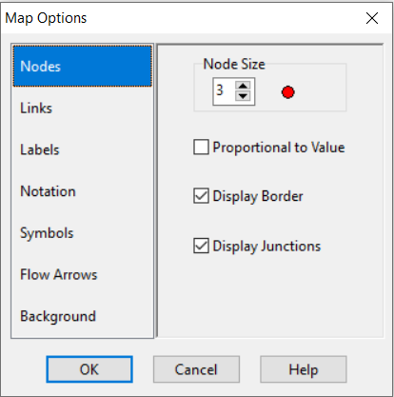

The dialog contains a separate page, selected from the panel on the left side of the form, for each of the following display option categories:

* *Nodes* (controls size of nodes and making size be proportional to value)
* *Links* (controls thickness of links, making thickness proportional to value)
* Labels (turns display of map labels on/off)
* *Notation* (displays or hides node/link ID labels and parameter values)
* *Symbols* (turns display of tank, pump, valve symbols on/off)
* *Flow Arrows* (selects visibility and style of flow direction arrows)
* *Background* (changes colour of map’s background)

**Node Options:**

The Nodes page of the Map Options dialog controls how nodes are displayed on the Network Map.

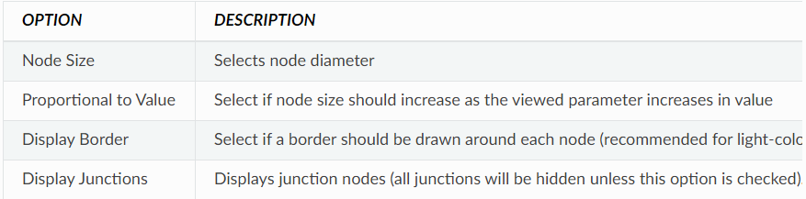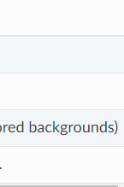

**Link Options:**

The Links page of the Map Options dialog controls how links are displayed on the map

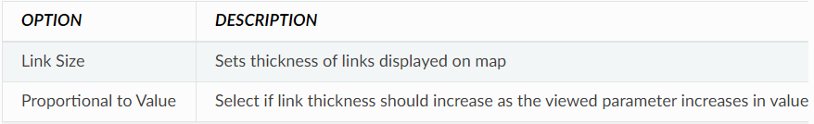

**Label Options:**

The Label page of the Map Options dialog controls how labels are displayed on the map.

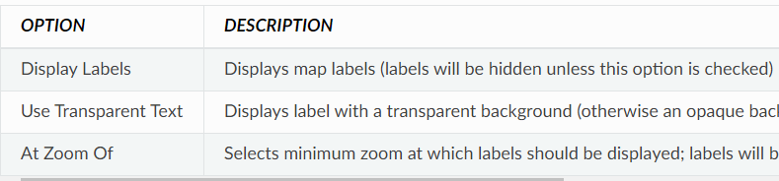

**Notation Options:**

The Notation page of the Map Options dialog form determines what kind of annotation is provided alongside of the nodes and links of the map.

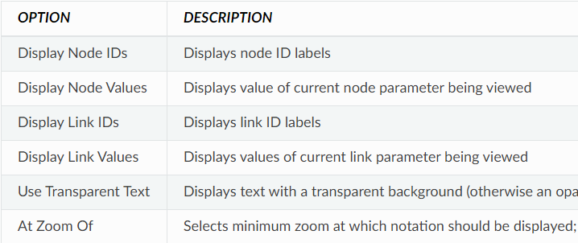

**Symbol Options**

The Symbols page of the Map Options dialog determines which types of objects are represented with special symbols on the map.

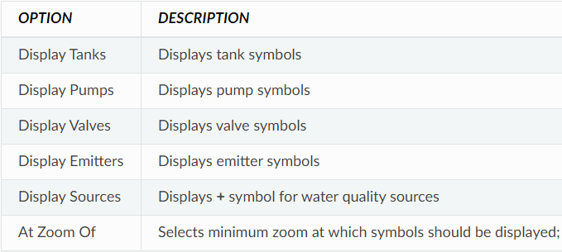

**Flow Arrow Options:**

The Flow Arrows page of the Map Options dialog controls how flow-direction arrows are displayed on the network map.

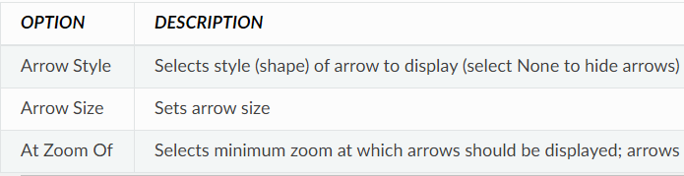

Flow direction arrows will only be displayed after a network has been successfully analysed.

**Background Options:**

The Background page of the Map Options dialog offers a selection of colours used to paint the map’s background with.

**Analysing a Network**

## **Setting Analysis Options:**

There are five categories of options that control how EPANET analyses a network: Hydraulics, Quality, Reactions, Times, and Energy. To set any of these options:

1. Select the Options category from the Data Browser or select **Project >> Analysis Options** from the menu bar.
2. Select Hydraulics, Quality, Reactions, Times, Energy from the Browser.
3. Edit your option choices in the Property Editor.

**Hydraulic Options:**

Hydraulic options control how the hydraulic computations are carried out.

|  |  |
| --- | --- |
| **OPTION** | **DESCRIPTION** |
| Flow Units | Units in which nodal demands and link flow rates are expressed. |
| Headloss Formula | Formula used to compute Headloss as a function of flow rate in a pipe. Hazen-Williams, Darcy-Weisbach, Chezy-Manning. Because each formula measures pipe roughness differently, switching formulas might require that all pipe roughness coefficients be updated. |
| Specific Gravity | Ratio of the density of the fluid being modelled to that of water at 4C |
| Relative Viscosity | Ratio of the kinematic viscosity of the fluid to that of water at 20C |
| Maximum Trials | Maximum number of trials used to solve the nonlinear equations that govern network hydraulics at a given point in time. Suggested value is 40. |
| Accuracy | Convergence criterion used to signal that a solution has been found to the nonlinear equations that govern network hydraulics. Trials end when the sum of all flow changes divided by the sum of all link flows is less than this number. Suggested value is 0.001. |
| If Unbalanced | Action to take if a hydraulic solution is not found within the maximum number of trials. Choices are STOP to stop the simulation at this point or CONTINUE to use another 10 trials, with no link status changes allowed, in an attempt to achieve convergence. |
| Default Pattern | ID label of a time pattern to be applied to demands at those junctions where no time pattern is specified. If no such pattern exists then demands will not vary at these locations. |
| Demand Multiplier | Global multiplier applied to all demands to make total system consumption vary up or down by a fixed amount |
| Emitter Exponent | Power to which pressure is raised when computing the flow through an emitter device. The textbook value for nozzles and sprinklers is 0.5. This may not apply to pipe leakage. |
| Status Report | Amount of status information to report after an analysis is made. Choices are: NONE (no reporting), YES (link status changes), FULL (normal plus convergence). Full status reporting is only useful for debugging purposes. |
| Max. Head Error | Augments the ACCURACY option. Specifies the maximum head loss error any network link can have for hydraulic convergence to occur. The default value of 0 indicates that no head error limit applies. |
| Max. Flow Change | Augments the ACCURACY option. Specifies the largest change in flow that any network element can have for hydraulic convergence to occur. The default value of 0 indicates that no flow change limit applies. It is specified based on the current project flow unit setting. |
| Demand Model | Selects between demand or pressure driven analysis – DDA or PDA, respectively. DDA assumes demands are fixed at a given point in time, while PDA assumes demands are a function of pressure. The PDA option can be used to find a solution when negative pressures are present in a DDA. |
| Minimum Pressure | In a PDA, the pressure below which demand is assumed to be zero. |
| Required Pressure | In a PDA, the pressure required to deliver the full demand. |
| Pressure Exponent | PDA assumes a pressure demand relation raised to an exponent. Standard value is 0.5. |
| CHECKFREQ | This sets the number of solution trials that pass during hydraulic balancing before the status of pumps, check valves, flow control valves and pipes connected to tanks are once again updated. The default value is 2, meaning that status checks are made every other trial. The frequency of status checks on pressure reducing and pressure sustaining valves (PRVs and PSVs) is determined by the DAMPLIMIT option. |
| MAXCHECK | This is the number of solution trials after which periodic status checks on pumps, check valves, flow control valves and pipes connected to tanks are discontinued. The default value is 10, meaning that after 10 trials, instead of checking status every CHECKFREQ trials, status is checked only at convergence. |
| DAMPLIMIT | This is the accuracy value at which solution damping and status checks on PRVs and PSVs should begin. The default is 0 which indicates that no damping should be used and that status checks on control valves are made at every iteration. Damping might be needed on networks that have trouble converging, in which case a limit of 0.01 is suggested. |

**Water Quality Options:**

Water Quality Options control how the water quality analysis is carried out.

|  |  |
| --- | --- |
| **OPTION** | **DESCRIPTION** |
| Parameter | Type of water quality parameter being modelled. Choices include: None, Chemical (compute concentration), Age (estimate water age), Trace (percent flow from node). In lieu of Chemical, you can enter the actual name of the chemical being modelled |
| Mass Units | Mass units used to express concentration. Choices are mg/L ug/L. Units for Age and Trace analyses are fixed at hours and percent. |
| Relative Diffusivity | Ratio of the molecular diffusivity of the chemical being modelled to that of chlorine at 20C, etc. Set to zero to ignore mass transfer effects. |
| Trace Node | D label of the node whose flow is being traced. Applies only to flow tracing analyses. |
| Quality Tolerance | Smallest change in quality that will cause a new parcel of water to be created in a pipe. A typical setting might be 0.01 for chemicals measured in mg/L as well as water age and source tracing. |

**Reaction Options:**

Reaction Options set the types of reactions that apply to a water quality analysis.

|  |  |
| --- | --- |
| **OPTION** | **DESCRIPTION** |
| Bulk Reaction Order | Power to which concentration is raised when computing a bulk flow reaction rate. Use 1 for first-order reactions, 2 for second-order reactions, etc. Use any negative number for Michaelis-Menton kinetics. If no global or pipe-specific bulk reaction coefficients are assigned then this option is ignored. |
| Wall Reaction Order | Power to which concentration is raised when computing a bulk flow reaction rate. Choices are 1 for first-order reactions 0 for constant rate reactions. If no global or pipe-specific wall reaction coefficients are assigned then this option is ignored. |
| Global Bulk Coefficient | Default bulk reaction rate coefficient Kb assigned to all pipes. Use a positive number for growth, a negative number for decay, or 0 if no bulk reaction occurs. |
| Global Wall Coefficient | Wall reaction rate coefficient Kw assigned to all pipes. Use a positive number for growth, a negative number for decay, or 0 if no wall reaction occurs. |
| Limiting Concentration | Maximum concentration that a substance can grow to or minimum value it can decay to. Set to zero if not applicable. |
| Wall Coefficient Correlation | Factor correlating wall reaction coefficient to pipe roughness. Set to zero if not applicable. |

**Times Options:**

Times options set values for the various time steps used in an extended period simulation.

|  |  |
| --- | --- |
| **OPTION** | **DESCRIPTION** |
| Total Duration | Total length of a simulation in hours. Use 0 to run a single period (snapshot) hydraulic analysis. |
| Hydraulic Time Step | Time interval between re-computation of system hydraulics. Normal default is 1 hour. |
| Quality Time Step | Time interval between routing of water quality constituent. Normal default is 5 minutes (0:05 hours). |
| Pattern Time Step | Time interval used with all the time patterns. Normal default is 1 hour. |
| Pattern Start Time | Hours into all the time patterns at which the simulation begins (e.g., a value of 2 means that the simulation begins with all the time patterns starting at their second hour). Normal default is 0. |
| Reporting Time Step | Time interval between times at which computed results are reported. Normal default is 1 hour. |
| Report Start Time | Hours into simulation at which computed results begin to be reported. Normal default is 0. |
| Starting Time of Day | Clock time (e.g., 7:30 am, 10:00 pm) at which simulation begins. Default is 12:00 am (midnight). |
| Statistic | Type of statistical processing used to summarize the results of an extended period simulation. Choices are: NONE (current time step results), AVERAGE (time-averaged results), MINIMUM (minimum value results), MAXIMUM (maximum value results), RANGE (diff between min and max). Statistical processing is applied to all node and link results obtained between the Report Start Time and the Total Duration. |

**Energy Options:**

Energy Analysis Options provide default values used to compute pumping energy and cost when no specific energy parameters are assigned to a given pump.

|  |  |
| --- | --- |
| **OPTION** | **DESCRIPTION** |
| Pump Efficiency (%) | Default pump efficiency. |
| Energy Price per KWH | Price of energy per kilowatt-hour. |
| Price Pattern | ID label of a time pattern used to represent variations in energy price with time. Leave blank if not applicable. |
| Demand Charge | Additional energy charge per maximum kilowatt usage. |

## **Running an Analysis:**

To run a hydraulic/water quality analysis:

1. Select **Project >> Run Analysis** or click image113 on the Standard Toolbar.
2. The progress of the analysis will be displayed in a Run Status window.
3. Click **OK** when the analysis ends.

If the analysis runs successfully the image114 icon will appear in the Run Status section of the Status Bar at the bottom of the EPANET workspace. Any error or warning messages will appear in a Status Report window. If you edit the properties of the network after a successful run has been made, the faucet icon changes to a broken faucet indicating that the current computed results no longer apply to the modified network.

**Viewing Results**

## **Viewing Results with a Graph:**

## Analysis results, as well as some design parameters, can be viewed using several different types of graphs. Graphs can be printed, copied to the Windows clipboard, or saved as a data file or Windows metafile.

|  |  |  |
| --- | --- | --- |
| **TYPE OF PLOT** | **DESCRIPTION** | **APPLIES TO** |
| Time Series Plot | Plots value versus time | Specific nodes or links over all time periods |
| Profile Plot | Plots value versus distance | A list of nodes at a specific time |
| Contour Plot | Shows regions of the map where values fall within specific intervals | All nodes at a specific time |
| Frequency Plot | Plots value versus fraction of objects at or below the value | All nodes or links at a specific time |
| System Flow | Plots total system production and consumption versus time | Water demand for all nodes over all time periods |

Types of Graphs Available to View Results

To create a graph:

1. Select **Report >> Graph** or click image117 on the Standard Toolbar.
2. Fill in the choices on the Graph Selection dialog box that appears.
3. Click **OK** to create the graph.

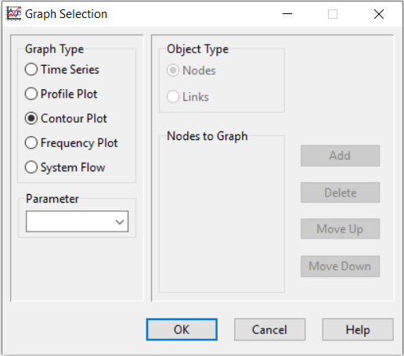

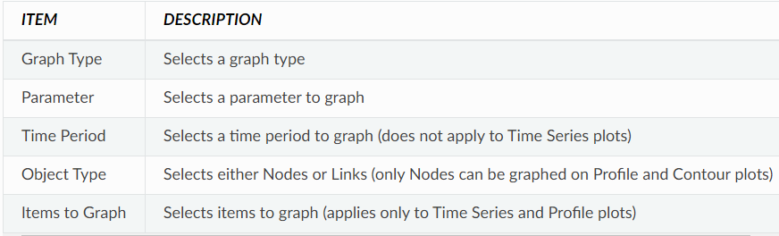

Time Series plots and Profile plots require one or more objects be selected for plotting. To select items into the Graph Selection dialog for plotting:

1. Select the object (node or link) either on the Network Map or on the Data Browser.
2. Click the **Add** button on the Graph Selection dialog to add the selected item to the list.

To customize the appearance of a graph:

1. Make the graph the active window (click on its title bar).
2. Select **Report >> Options**, or click image124 on the Standard Toolbar, or right-click on the graph.
3. For a Time Series, Profile, Frequency or System Flow plot, use the resulting Graph Options dialog to customize the graph’s appearance.

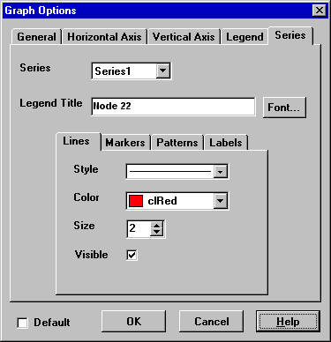

The Graph Options dialog form is used to customize the appearance of an X-Y graph. To use the dialog box:

1. Select from among the five tabbed pages that cover the following categories of options:
   * General
   * Horizontal Axis
   * Vertical Axis
   * Legend
   * Series
2. Check the **Default** box if you wish to use the current settings as defaults for all new graphs as well.
3. Select **OK** to accept your selections.

Graph Options General Tab

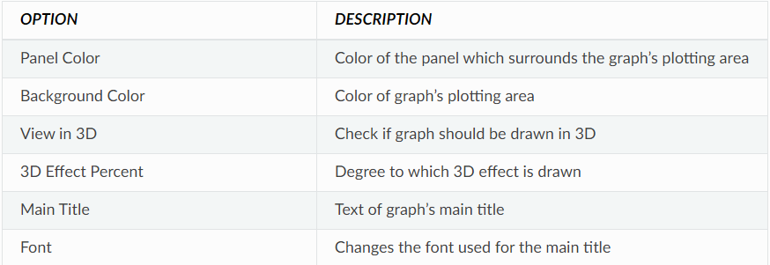

Graph Options Horizontal and Vertical Axis Tabs

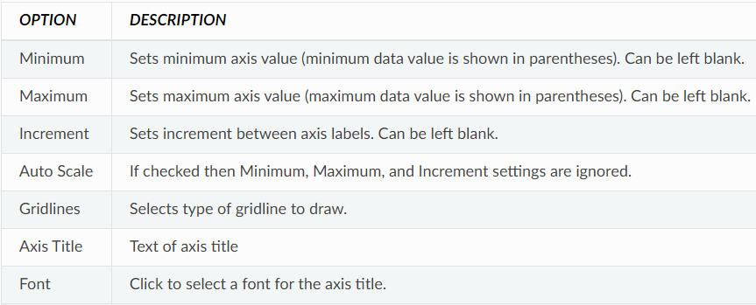

Graph Options Legend Tab

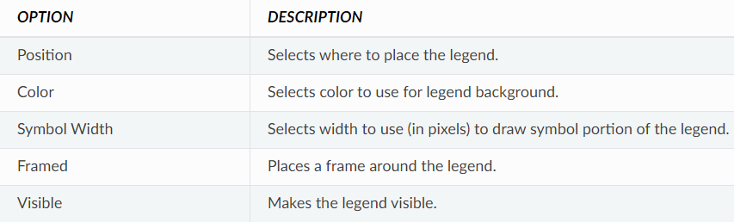

The Series tab of the Graph Options dialog controls how individual data series (or curves) are displayed on a graph. To use this page:

* Select a data series to work with from the Series combo box.
* Edit the title used to identify this series in the legend.
* Click the Font button to change the font used for the legend. (Other legend properties are selected on the Legend page of the dialog.)
* Select a property of the data series you would like to modify. The choices are:
  + Lines
  + Markers
  + Patterns
  + Labels

(Not all properties are available for some types of graphs.)

Graph Options Series Tab

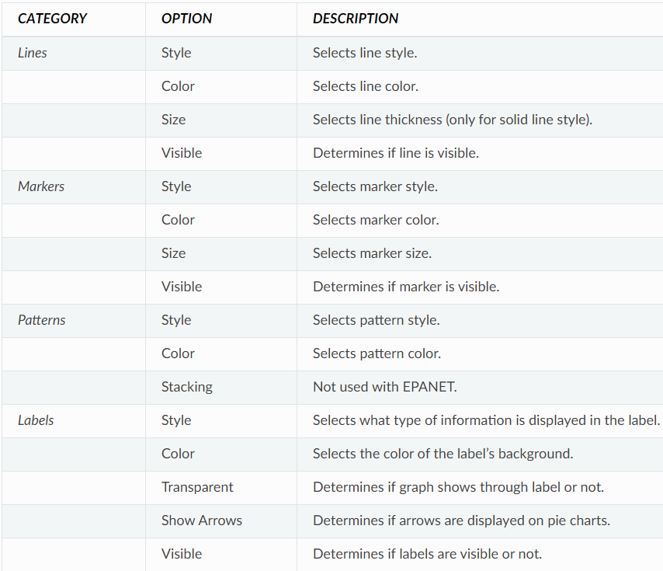

## **Viewing Results with a Table:**

EPANET allows you to view selected project data and analysis results in a tabular format:

* A Network Table lists properties and results for all nodes or links at a specific period of time.
* A Time Series Table lists properties and results for a specific node or link in all time periods.

Tables can be printed, copied to the Windows clipboard, or saved to file.

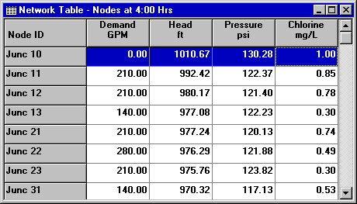

To create a table:

1. Select **View >> Table** or click image127 on the Standard Toolbar.
2. Use the Table Options dialog box that appears to select:
   * The type of table
   * The quantities to display in each column
   * Any filters to apply to the data

The Table Selection options dialog form has three tabs. All three tabs are available when a table is first created. After the table is created, only the Columns and Filters tabs will appear.

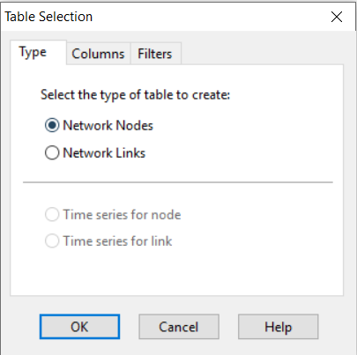

**Type Tab:**

The Type tab of the Table Options dialog is used to select the type of table to create. The choices are:

* All network nodes at a specific time period
* All network links at a specific time period
* All time periods for a specific node
* All time periods for a specific link

Data fields are available for selecting the time period or node/link to which the table applies.

**Columns Tab:**

The Columns tab of the Table Options dialog form selects the parameters that are displayed in the table’s columns.

* Click the checkbox next to the name of each parameter you wish to include in the table.
* To sort a Network-type table with respect to the values of a particular parameter, select the parameter from the list and check off the **Sorted By** box at the bottom of the form. (The sorted parameter does not have to be selected as one of the columns in the table.) Time Series tables cannot be sorted.

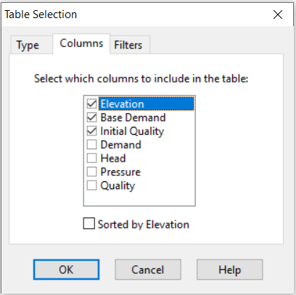

**Filters Tab:**

The Filters tab of the Table Options dialog form is used to define conditions for selecting items to appear in a table. To filter the contents of a table:

* Use the controls at the top of the page to create a condition.
* Click the **Add** button to add the condition to the list.
* Use the **Delete** button to remove a selected condition from the list.

Multiple conditions used to filter the table are connected by AND’s. If a table has been filtered, a re-sizeable panel will appear at the bottom indicating how many items have satisfied the filter conditions.

**Viewing Special Reports:**

In addition to graphs and tables, EPANET can generate several other specialized reports. These include:

* Status Report
* Energy Report
* Calibration Report
* Reaction Report
* Full Report

All of these reports can be printed, copied to a file, or copied to the Windows clipboard (the Full Report can only be saved to file.)

**Status Report:**

EPANET writes all error and warning messages generated during an analysis to a Status Report. Additional information on when network objects change status and a final mass balance accounting for water quality analysis are also written to this report if the Status Report option in the project’s Hydraulics Options was set to Yes or Full. To view a status report on the most recently completed analysis select **Report >> Status** from the main menu.

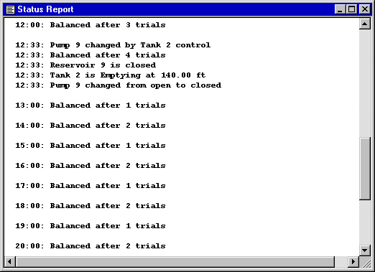

**Energy Report:**

EPANET can generate an Energy Report that displays statistics about the energy consumed by each pump and the cost of this energy usage over the duration of a simulation. To generate an Energy Report, select **Report >> Energy** from the main menu. The report has two tabs, Table and Chart. One displays energy usage by pump in a tabular format. The second compares a selected energy statistic between pumps using a bar chart.

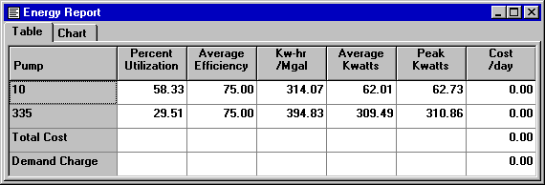

**Reaction Report:**

A Reaction Report, available when modelling the fate of a reactive water quality constituent, graphically depicts the overall average reaction rates occurring throughout the network in the following locations:

* The bulk flow
* The pipe walls
* Within storage tanks

A pie chart shows what percent of the overall reaction rate is occurring in each location. The chart legend displays the average rates in mass units per hour. A footnote on the chart shows the inflow rate of the reactant into the system.

A Graph Options dialog box can be called up to modify the appearance of the pie chart by selecting **Report >> Options** or by clicking image138 on the Standard Toolbar, or by right-clicking anywhere on the chart.

**Full Report:**

When the image139 icon appears in the Run Status section of the Status Bar, a report of computed results for all nodes, links and time periods can be saved to file by selecting **Full** from the **Report** menu. This report, which can be viewed or printed outside of EPANET using any text editor or word processor, contains the following information:

* Project title and notes
* A table listing the end nodes, length, and diameter of each link
* A table listing energy usage statistics for each pump
* A pair of tables for each time period listing computed values for each node (demand, head, pressure, and quality) and for each link (flow, velocity, Headloss, and status)

This feature is useful mainly for documenting the final results of a network analysis on small to moderately sized networks.

**Importing and Exporting**

## **Importing a Network Map:**

To import the coordinates for a network map stored in a text file:

1. Select **File >> Import >> Map** from the main menu.
2. Select the file containing the map information from the Open File dialog that appears.
3. Click **OK** to replace the current network map with the one described in the file.

## **Exporting the Network Map:**

The current view of the network map can be saved to file using either Autodesk’s DXF (Drawing Exchange Format) format, the Windows enhanced metafile (EMF) format, or EPANET’s own ASCII text (map) format. The DXF format is readable by many Computer Aided Design (CAD) programs. Metafiles can be inserted into word processing documents and loaded into drawing programs for re-scaling and editing. To export the network map at full extent to a DXF, metafile, or text file:

1. Select **File >> Export >> Map** from the main menu.
2. In the Map Export dialog form that appears select the format that you want the map saved in.
3. If you select DXF format, you have a choice of how junctions will be represented in the DXF file.
4. After choosing a format, click OK and enter a name for the file in the Save As dialog form that appears.

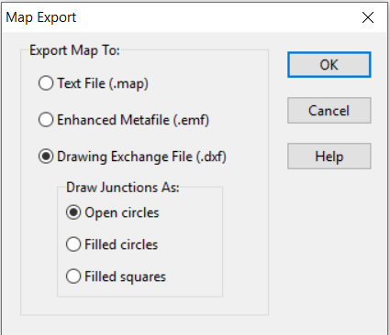

## **Exporting to a Text File:**

To export a project’s data to a text file:

1. Select **File >> Export >> Network** from the main menu.
2. In the Save dialog form that appears enter a name for the file to save to (the default extension is. INP).
3. Click **OK** to complete the export.

The resulting file will be written in ASCII text format, with the various data categories and property labels clearly identified. It can be read back into EPANET for analysis at another time by using either the **File >> Open** or **File >> Import >> Network** commands. Complete network descriptions using this input format can also be created outside of EPANET using any text editor or spreadsheet program.

## **Example Network:**

In this tutorial we will analyse the simple distribution network shown in [Figure](https://epanet22.readthedocs.io/en/latest/2_quickstart.html#fig-ex-pipe-network) below. It consists of a source reservoir (e.g., a treatment plant clears well) from which water is pumped into a two-loop pipe network. There is also a pipe leading to a storage tank that floats on the system. The ID labels for the various components are shown in the figure. The nodes in the network have the characteristics shown in [Table 1](https://epanet22.readthedocs.io/en/latest/2_quickstart.html#table-ex-network-node-prop). Pipe properties are listed in [Table 2](https://epanet22.readthedocs.io/en/latest/2_quickstart.html#table-ex-network-pipe-prop). In addition, the pump (Link 9) can deliver 150 ft of head at a flow of 600 gpm, and the tank (Node 8) has a 60-ft diameter, a 3.5-ft water level, and a maximum level of 20 feet.

Figure



Figure1: Example pipe network.

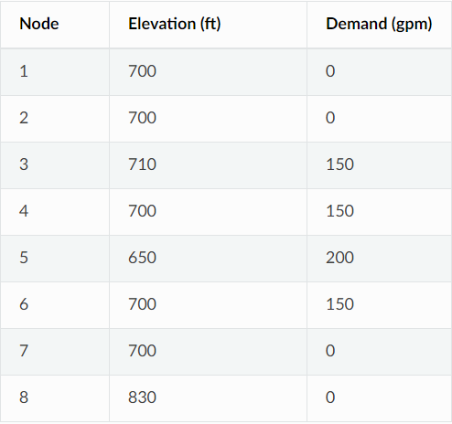 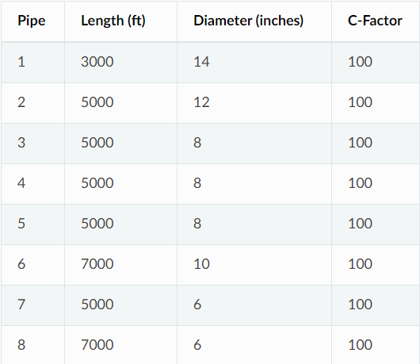

Table1: Example Network Node Properties Table2: Example Network Pipe Properties

**Project Setup:**

Our first task is to create a new project in EPANET and make sure that certain default options are selected. To begin, select **File >> New** (from the menu bar) to create a new project. Then select **Project** **>> Defaults** to open the dialog form shown in Figure 2. We will use this dialog to have EPANET automatically label new objects with consecutive numbers starting from 1 as they are added to the network. On the ID Labels page of the dialog, clear all of the ID Prefix fields and set the ID Increment to 1. Then select the Hydraulics page of the dialog and set the choice of Flow Units to GPM (gallons per minute). Also select Hazen - Williams (H-W) as the head loss formula. If you wanted to save these choices for all future new projects you could check the **Save** box at the bottom of the form before accepting it by clicking the **OK** button.

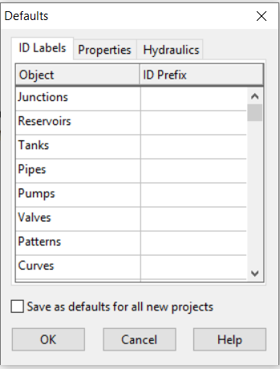 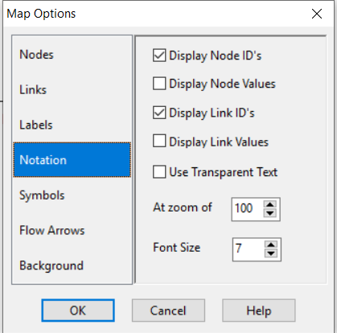

Figure2: Project defaults dialog. Figure3: Map options dialog

Next, we will select some map display options so that as we add objects to the map, we will see their ID labels and symbols displayed. Select **View >> Options** to bring up the Map Options dialog form. Select the Notation page on this form and check the settings shown in Figure 3. Then switch to the Symbols page and check all of the boxes. Click the **OK** button to accept these choices and close the dialog.

Finally, before drawing our network we should ensure that our map scale settings are acceptable. Select **View >> Dimensions** to bring up the Map Dimensions dialog. Note the default dimensions assigned for a new project. These settings will suffice for this example, so click the **OK** button.

## **Drawing the Network:**

We are now ready to begin drawing our network by making use of our mouse and the buttons contained on the Map Toolbar shown below. (If the toolbar is not visible then select **View >> Toolbars >> Map**).



First, we will add the reservoir. Click the Reservoir button image4. Then click the mouse on the map at the location of the reservoir (somewhere to the left of the map). Next, we will add the junction nodes. Click the Junction button image5 and then click on the map at the locations of nodes 2 through 7. Finally add the tank by clicking the Tank button image6 and clicking the map where the tank is located. At this point the Network Map should look something like the drawing in Figure 4.

Next, we will add the pipes. Let’s begin with pipe 1 connecting node 2 to node 3. First click the Pipe button image8 on the Toolbar. Then click the mouse on node 2 on the map and then on node 3. Note how an outline of the pipe is drawn as you move the mouse from node 2 to 3. Repeat this procedure for pipes 2 through 7. Pipe 8 is curved. To draw it, click the mouse first on Node 5. Then as you move the mouse towards Node 6, click at those points where a change of direction is needed to maintain the desired shape. Complete the process by clicking on Node 6. Finally, we will add the pump. Click the Pump button image9, click on node 1 and then on node 2.

Next, we will label the reservoir, pump and tank. Select the Text button image10 on the Map Toolbar and click somewhere close to the reservoir (Node 1). An edit box will appear. Type in the word SOURCE and then hit the **Enter** key. Click next to the pump and enter its label, then do the same for the tank. Then click the Selection button image11 on the Toolbar to put the map into Object Selection mode rather than Text Insertion mode.

At this point we have completed drawing the example network. Your Network Map should look like the map in Figure1. If the nodes are out of position you can move them around by clicking the node to select it, and then dragging it with the left mouse button held down to its new position. Note how pipes connected to the node are moved along with the node. The labels can be repositioned in similar fashion. To re - shape the curved Pipe 8:

1. First click on Pipe 8 to select it and then click the image12 button on the Map Toolbar to put the map into Vertex Selection mode.
2. Select a vertex point on the pipe by clicking on it and then drag it to a new position with the left mouse button held down.
3. If required, vertices can be added or deleted from the pipe by right- clicking the mouse and selecting the appropriate option from the popup menu that appears.
4. When finished, click image13 to return to Object Selection mode.

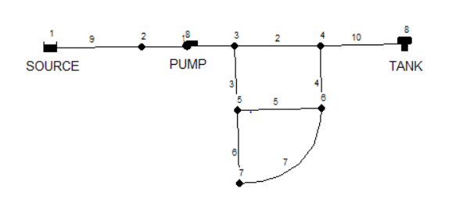

## **Setting Object Properties:**

As objects are added to a project, they are assigned a default set of properties. To change the value of a specific property for an object one must select the object into the Property Editor (Figure 5):

* Double-click the object on the map
* Right-click on the object and select **Properties** from the pop-up menu that appears
* Select the object from the Data page of the Browser window and then click the Browser’s Edit button image14

Whenever the Property Editor has the focus you can press the F1 key to obtain fuller descriptions of the properties listed.

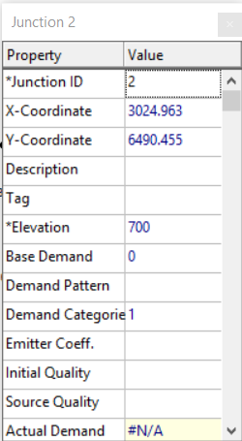

Figure5: Property editor.

Let us begin editing by selecting Node 2 into the Property Editor as shown above. We would now enter the elevation and demand for this node in the appropriate fields.

For the reservoir you would enter its elevation (700) in the Total Head field. For the tank, enter 830 for its elevation, 4 for its initial level, 20 for its maximum level, and 60 for its diameter. For the pump, we need to assign it a pump curve (head versus flow relationship). Enter the ID label 1 in the Pump Curve field.

Next, we will create Pump Curve 1. From the Data page of the Browser window, select Curves from the dropdown list box and then click the Add button image16. A new Curve 1 will be added to the database and the Curve Editor dialog form will appear (see Figure 6). Enter the pump’s design flow (600) and head (150) into this form. EPANET automatically creates a complete pump curve from this single point. The curve’s equation is shown along with its shape. Click **OK** to close the Editor.



Figure 6: Curve editor.

## **Saving and Opening Projects:**

1. From the **File** menu select the **Save As** option.
2. In the Save As dialog that appears, select a folder and file name under which to save this project. We suggest naming the file **tutorial.net**. (An extension of **.net** will be added to the file name if one is not supplied.).
3. Click **OK** to save the project to file.

The project data is saved to the file in a special binary format. If you wanted to save the network data to file as readable text, use the **File >> Export >> Network** command instead.

To open our project at some later time, we would select the **Open** command from the **File** menu.

## **Running a Single Period Analysis:**

To run the analysis, select **Project >> Run Analysis** or click the Run button image18 on the Standard Toolbar.

If the run was unsuccessful then a Status Report window will appear indicating what the problem was. If it ran successfully you can view the computed results in a variety of ways. Try some of the following:

* Select Node Pressure from the Browser’s Map page and observe how pressure values at the nodes become color-coded. To view the legend for the color-coding, select **View >> Legends >> Node** (or right- click on an empty portion of the map and select Node Legend from the popup menu). To change the legend intervals and colours, right-click on the legend to make the Legend Editor appear.

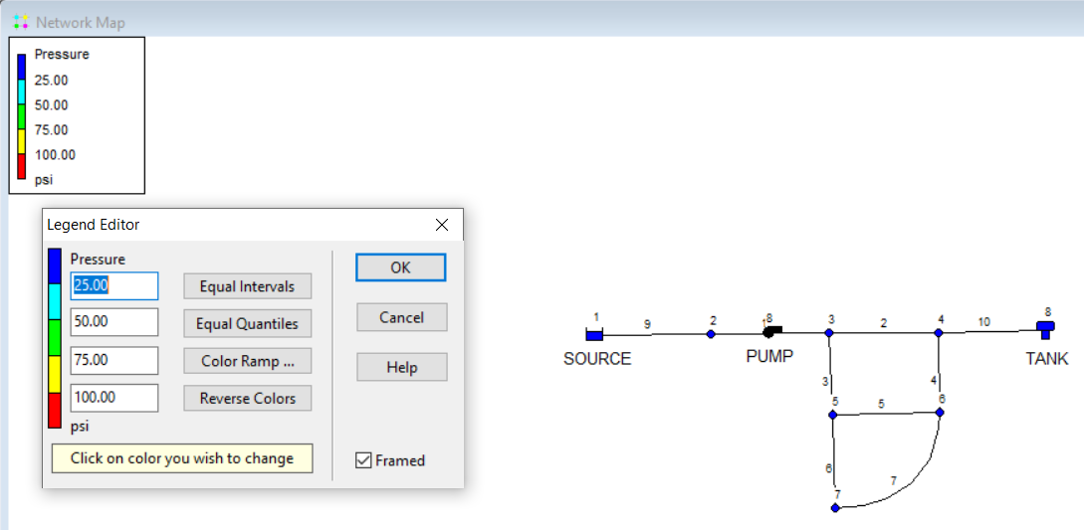

* Bring up the Property Editor (double-click on any node or link) and note how the computed results are displayed at the end of the property list.
* Create a tabular listing of results by selecting **Report >> Table** (or by clicking the Table button image19 on the Standard Toolbar). Figure 7 displays such a table for the link results of this run. Note that flows with negative signs means that the flow is in the opposite direction to the direction in which the pipe was drawn initially.

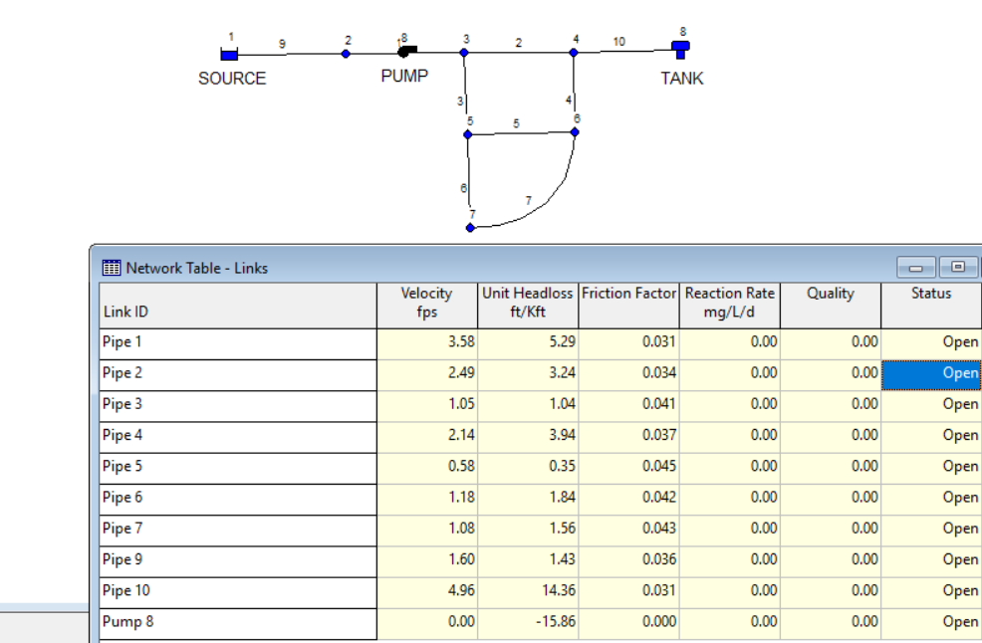

Figure 7: Results

## **Running an Extended Period Analysis:**

To make our network more realistic for analysing an extended period of operation we will create a Time Pattern that makes demands at the nodes vary in a periodic way over the course of a day. For this simple example we will use a pattern time step of 6 hours thus making demands change at four different times of the day. We set the pattern time step by selecting Options-Times from the Data Browser, and entering 6 for the value of the Pattern Time Step. Let’s use a 3-day period of time (enter 72 hours for the Duration property).

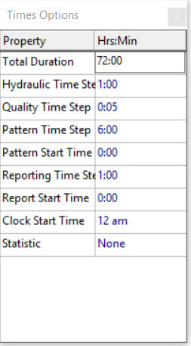

To create the pattern, select the Patterns category in the Browser and then click the Add button image22. A new Pattern 1 will be created and the Pattern Editor dialog should appear. Enter the multiplier values 0.5, 1.3, 1.0, 1.2 for the time periods 1 to 4 that will give our pattern a duration of 24 hours. The multipliers are used to modify the demand from its base level in each time period. Since we are making a run of 72 hours, the pattern will wrap around to the start after each 24-hour interval of time.



We now need to assign Pattern 1 to the Demand Pattern property of all of the junctions in our network.  If you bring up the Hydraulic Options in the Property Editor you will see that there is an item called Default Pattern. Setting its value equal to 1 will make the Demand Pattern at each junction equal Pattern 1, as long as no other pattern is assigned to the junction.

Next run the analysis (select **Project >> Run Analysis).**

For extended period analysis you have several more ways in which to view results:

* The scrollbar in the Browser’s Time controls is used to display the network map at different points in time. Try doing this with Pressure selected as the node parameter and Flow as the link parameter.
* Add flow direction arrows to the map (select **View >> Options**, select the Flow Arrows page from the Map Options dialog, and check a style of arrow that you wish to use). Then begin the animation again and note the change in flow direction through the pipe connected to the tank as the tank fills and empties over time.
* Create a time series plot for any node or link. For example, to see how the water elevation in the tank changes with time:
  + Click on the tank.
  + Select **Report >> Graph** (or click the Graph button image27 on the Standard Toolbar) which will display a Graph Selection dialog box.
  + Select the Time Series button on the dialog.
  + Select Head as the parameter to plot.
  + Click **OK** to accept your choice of graph.

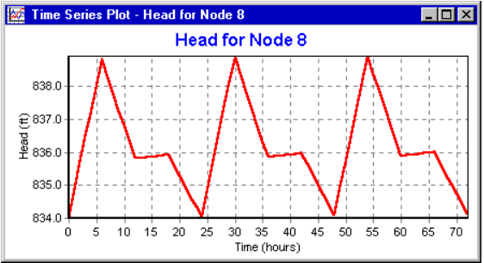

## **Running a Water Quality Analysis:**

Next, we show how to extend the analysis of our example network to include water quality. The simplest case would be tracking the growth in water age throughout the network over time. To make this analysis we only have to select Age for the Parameter property in the Quality Options.

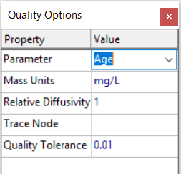

Finally, we show how to simulate the transport and decay of chlorine through the network. Make the following changes to the database:

1. Select Options-Quality to edit from the Data Browser. In the Property Editor’s Parameter field type in the word Chlorine.
2. Switch to Options-Reactions in the Browser. For Global Bulk Coefficient enter a value of -1.0. This reflects the rate at which chlorine will decay due to reactions in the bulk flow over time. This rate will apply to all pipes in the network. You could edit this value for individual pipes if you needed to.
3. Click on the reservoir node and set its Initial Quality to 1.0. This will be the concentration of chlorine that continuously enters the network. (Reset the initial quality in the Tank to 0 if you had changed it.)

Now run the example. Use the Time controls on the Map Browser to see how chlorine levels change by location and time throughout the simulation. Create a reaction report for this run by selecting **Report >> Reaction** from the main menu. It shows on average how much chlorine loss occurs in the pipes as opposed to the tank. The term “bulk” refers to reactions occurring in the bulk fluid while “wall” refers to reactions with material on the pipe wall. The latter reaction is zero because we did not specify any wall reaction coefficient in this example.

